Arduino Pulse Sensor
呂芳元2015 /12/ 2
http://www.rasvector.url.tw/
說明 :
使用 Arduino + Pulse Sensor 擷取心脈波訊號，以 RGB LED 顯示心跳快慢程度，並將心脈波、心跳數據傳送到 PC端顯示波形。

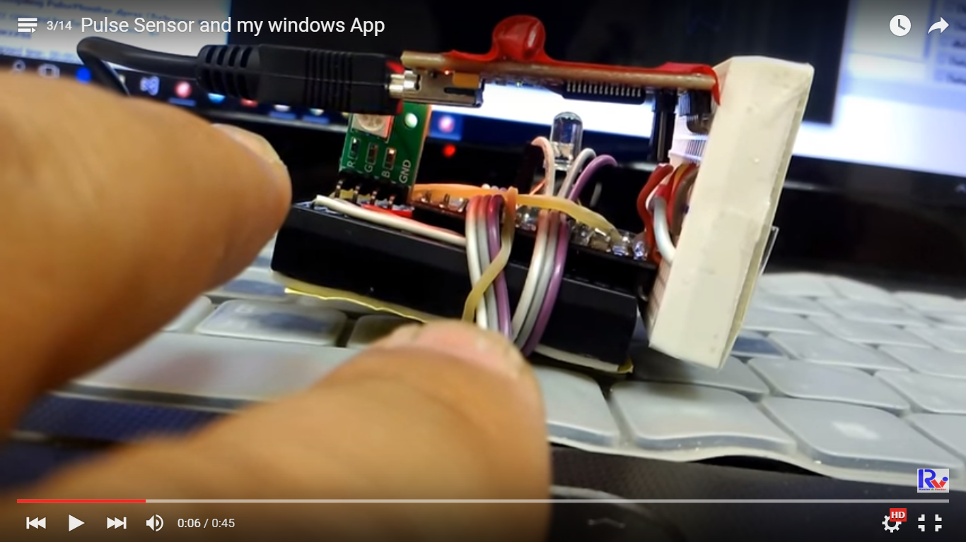
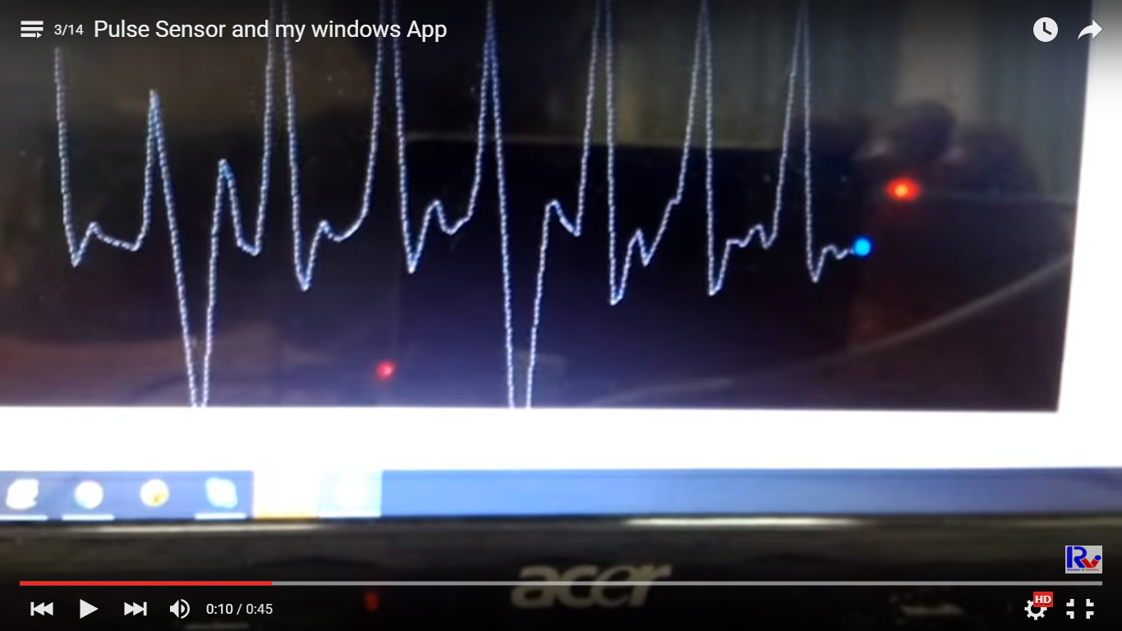
影片:
https://www.youtube.com/watch?v=0CKQ7as65yc&index=5&list=PLZG_AEGYW1gIMxUBlrYXnEpwFF9LIxn3T
https://www.youtube.com/watch?v=p0KdO7rtU7o&list=PLZG_AEGYW1gIMxUBlrYXnEpwFF9LIxn3T

Arduino 程式碼、線路圖、PC端程式、說明 下載:
https://www.dropbox.com/sh/iy5nacruhfk7c28/AADUfQWsaexbhZdodKG-M77Pa?dl=0

材料:

USB_To_TTL x1 用來將 Arduino程式碼燒錄到 Arduino，和將心跳數據傳回PC。
Arduino ProMini x1 用來控制 LED閃爍和接收Pulse Sensor數據。
Pulse Sensor x1 用來接收人體上的心跳、心脈波數據。
共陰極RGB LED x1 以 紅色(心跳快) -> 綠色 -> 藍色(心跳慢) 用來顯示心跳快慢程度。
單色 LED x1 用來做心跳指示燈。

。
線材:
杜邦線 ( 公/公、公/母、母/母 )各 10 條以上、麵包版。

USB to TTL 模組
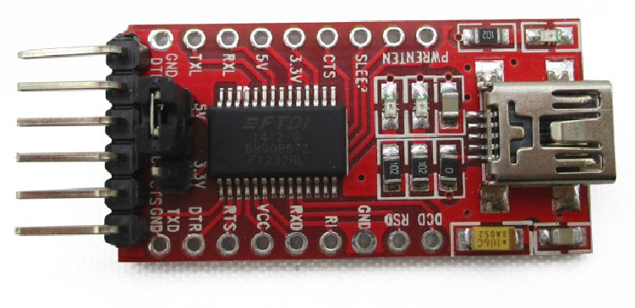

Arduino ProMini
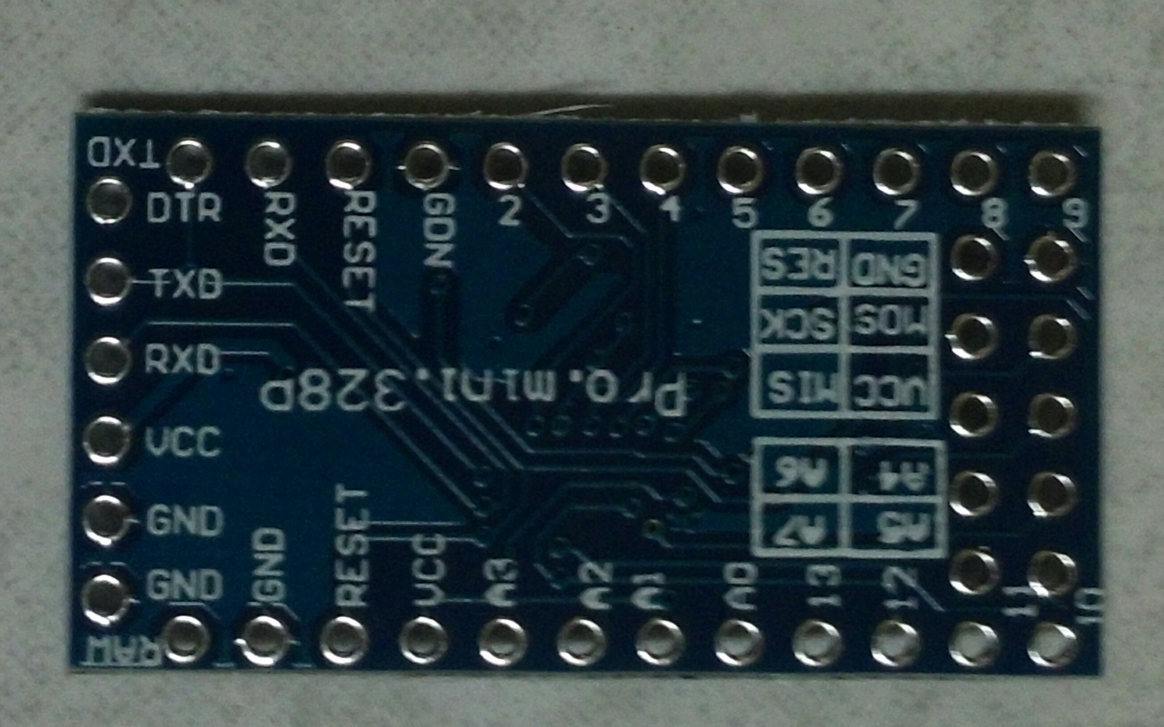

Pulse Sensor
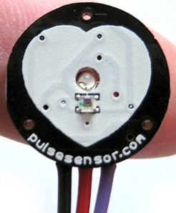

線路:
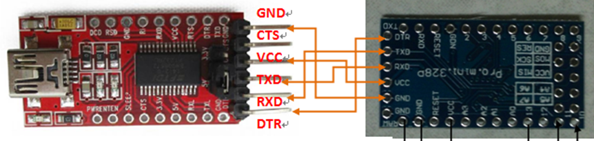

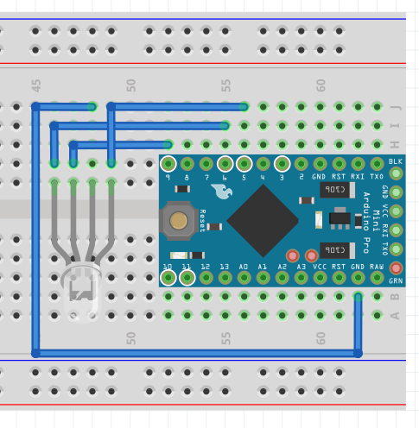
G B - R

Arduino程式碼:

主程式PulseSensor_BlinkLed.ino
/*
使用 Timer2 中斷服務，擷取 PulseSensor 的數值

Daniel Lu : dan59314@gmail.com
http://www.rasvector.url.tw/
http://www.youtube.com/dan59314/playlist

blinkPin : 當心跳訊號出現時，用來快閃
fadPin : 心跳訊號出現後，用來漸暗 LED

指令 :
Serial.print(78, BIN) gives "1001110"
Serial.print(78, OCT) gives "116"
Serial.print(78, DEC) gives "78"
Serial.print(78, HEX) gives "4E"
Serial.println(1.23456, 0) gives "1"
Serial.println(1.23456, 2) gives "1.23"
Serial.println(1.23456, 4) gives "1.2346"
Serial.println("S," + String(pulseVal) + "," + String(gTotalTime, HEX));

*/

#include <SoftwareSerial.h>

#define EnableReceiveCommand
#define AverageHeartBeat;
#define RGBColorFadding
#define UseTimer2IRS
#define CommonAnode

#define debug

typedef struct TRGB {
byte R, G, B;
unsigned long DelayMSec;
};

#ifdef EnableReceiveCommand
const byte cMaxCommandCount = 5;
const int cMaxCommandStringLength = 10; // length("C,255,255,255,12345");
String inputBtString = "", inputPcString = "",
sCommand[cMaxCommandCount] = { "D","13","0","0","0" }; //將 Digitial Pin 13 設為 0;
bool stringBtComplete = false, stringPcComplete;
byte pinRx =10, pinTx =11;
unsigned long gLastListerningTime, gLastActionTime;

// BlueTooth in Pin10(RX) Pin11(TX) PWM Pin -------------------------
SoftwareSerial BlueToothSerial(pinRx, pinTx); //10, 11); // RX, TX
#endif

#ifdef AverageHeartBeat
const int cHeartBeatCount = 10;
#endif

#ifndef UseTimer2IRS
unsigned long gLastCheckMs;
#endif

const int cRamboCount = 20;
const int cHeartBeatMin = 40, cHeartBeatMax = 120;
const int cHeartBeatStep = (cHeartBeatMax - cHeartBeatMin) / cRamboCount;
const int cFadeStep = 10;
const int cTimer2IntervalMSec=2; // 設定每2毫秒一次中斷
const byte cMinSampeDurationMsec = 250; // 取樣最小間隔毫秒
const byte cSampleCount = 10; // 取樣數
const byte cOuputIntervalMSec = 50; // 每50毫秒輸出一次

const byte funcOutputPulse=1;
const byte funcAveragePulse=2;
const byte funcOneColorFadding =4;

TRGB gRamboRGBs[cRamboCount];

// Timer2 掌管 PWM pin 3, 11, 因此不能使用這兩個 Pin -----------------
int pulsePin = 0; // 連接到 Pulse Sensor 的 A 訊號
int blinkPin = 13; // 用來快閃顯示心跳訊號
int fadePinR = 5, fadePinG = 6, fadePinB = 9; // 用來漸暗心跳訊號出現後的

// 因為這些變數使用在 ISR (中斷 Rountine 內)，因此須加 volatile -------------------------------------------

#ifdef AverageHeartBeat
volatile int gHeartBeats[cHeartBeatCount];
volatile int gCurHeartBeatId=0;
#endif

volatile int BPM; // 心跳，次/分
volatile int gPeakTime = 600; // 紀錄目前的心跳間隔時間
volatile boolean blInPeakPulse = false; // true when pulse wave is high, false when it's low
volatile boolean blOutputHeartBeat = false; // becomes true when Arduoino finds a beat.
volatile int gMin_PeakTime = 60000 / 200; // 假設最大心跳 200次/分，則最小間隔時間為 60000/200
volatile int gCurSampleID = 0; // 目前 Sample ID
volatile int PulseDurations[cSampleCount]; // 心跳間隔時間取樣陣列
volatile unsigned long gLastBeatTime = 0; // 上一次心跳波峰時間
volatile unsigned long gTotalTime = 0; // 總共經過時間
volatile int gCurMaxPulse = 512; // 最高 Pulse 波峰
volatile int gCurMinPulse = 512; // 最低 Pulse 波峰
volatile int gLastPulseThreshold = 512; // 紀錄最近的 Pulse Value 平均值
volatile byte decR = 255/cFadeStep, decG = decR, decB = decR;
volatile int gFadeValueR = 0, gFadeValueG = 0, gFadeValueB = 0; // 用來更新 FadePin 的 PWM 數值
volatile byte gFunctions =0x00000000;

void buildRamboRGBs(bool ignoreBlueToRed=true)
{
const byte cR = 0, cG = 1, cB = 2;

byte aR, aG, aB;
aR = 255;
aG = 0;
aB = 0;

byte aRGB = 0;
byte rangeN = 3;
if (ignoreBlueToRed) rangeN = 2;
else rangeN = 3;
byte cRamboStep = (255 * rangeN / (cRamboCount)); // 限制在 R-G, G-B, 因此 rangeN=2

for (int i = cRamboCount - 1; i>=0; i--) //從 B 開始往前填入
{
gRamboRGBs[i].R = aR;
gRamboRGBs[i].G = aG;
gRamboRGBs[i].B = aB;
gRamboRGBs[i].DelayMSec = 10000 / cRamboCount;

String s1 = "R" + String(aR) + ", G" + String(aG) + ", B" + String(aB);
Serial.println(s1);

if (aRGB == cR)
{
aR -= cRamboStep;
aG += cRamboStep;
if (aR<cRamboStep)
{
aR = 0;
aG = 255;
aB = 0;
aRGB = cG;
}
}
else if (aRGB == cG)
{
aG -= cRamboStep;
aB += cRamboStep;
if (aG<cRamboStep)
{
aG = 0;
aB = 255;
aR = 0;
aRGB = cB;
}
}
else //if (aRGB=cB)
{
aB -= cRamboStep;
aR += cRamboStep;
if (aB<cRamboStep)
{
aB = 0;
aR = 255;
aG = 0;
aRGB = cR;
}
}
}

}

void initial_Variables()
{
#ifndef UseTimer2IRS
gLastCheckMs = millis();
#endif

// 給予取樣心跳陣列初值 -------------------------------------
for (int i = 0; i<cSampleCount; i++)
PulseDurations[i] = 60000 / 72;

#ifdef AverageHeartBeat
// 給予 gHeartBeats 初值 ---------------------------------------
for (int i = 0; i < cHeartBeatCount; i++)
gHeartBeats[i]=72;
#endif
}

#ifdef EnableReceiveCommand

bool GetCompleteStringFromBlueTooth(String &str)
{
while (BlueToothSerial.available()) {

// 逐一加入字元直到遇到 \n--------------------
char inChar = (char)BlueToothSerial.read();

// 如果字元 = \n 則跳出 -----------
if ((inChar == '\r') || (inChar == '\n') || (str.length() > cMaxCommandStringLength))
{
return (str != "");
}
else
{
str += inChar;
return false;
}
}

return false;
}

bool GetCompleteStringFromPC(String &str)
{
while (Serial.available()) {
// 逐一加入字元直到遇到 \n--------------------
char inChar = (char)Serial.read();

// 如果字元 = \n 則跳出 -----------
if ((inChar == '\r') || (inChar == '\n') || (str.length() > cMaxCommandStringLength))
{
return (str != "");
}
else
{
str += inChar;
return false;
}
}

return false;
}

bool GetCommand(String inStr, String sCmd[], int &cmdCnt) // call by reference, 陣列不需加 &
{
//int cmdCnt=0;
char *p = &inStr[0];
char *str;

cmdCnt = 0;

// 以 "," 來拆解字串----------------------------------------
while (cmdCnt<cMaxCommandCount && (str = strtok_r(p, ",", &p)) != NULL)
{
sCommand[cmdCnt] = str;
sCommand[cmdCnt].toUpperCase();
cmdCnt++;
}

#ifdef debug
//Serial.println(cmdCnt);
#endif

return (cmdCnt>0);
}

void Process_Command(String sCmd[])
{
#ifdef debug
/*Serial.println("Process_Command() ");
Serial.println(sCmd[0]);
Serial.println(sCmd[1]);
Serial.println(sCmd[2]);
Serial.println(sCmd[3]);*/
#endif

// P,0/1 取消/啟動 輸出 Pulse ----------------
if (sCmd[0].indexOf("FN") == 0 || sCmd[0].indexOf("fn") == 0) // Analog
{
gFunctions = sCmd[1].toInt();
#ifdef debug
Serial.print("FN: "); Serial.println(gFunctions, BIN);
#endif
}
else if (sCmd[0].indexOf("T") == 0 || sCmd[0].indexOf("t") == 0) //TI, TD
{

if (sCmd[0].indexOf("D") == 1 || sCmd[0].indexOf("d") == 1) // TD,200 delay msec
{
//gDelayMsec = sCmd[1].toInt();
//String s1 = "DelayMSec : " + sCmd[1];
//Serial.println(s1);
}
else if (sCmd[0].indexOf("I") == 1 || sCmd[0].indexOf("i") == 1) // TI, 2000 Idel time msec
{
//gIdleMsec = sCmd[1].toInt() % cMaxIdleMsec;

//String s1 = "IdleMSec : " + sCmd[1];
//Serial.println(s1);
}
else;
}
else
{
#ifdef debug
BlueToothSerial.println("Command : " + sCmd[0] + "-" + sCmd[1] + "-" + sCmd[2] + "not processed");
#endif
}
}
#endif

void setup()
{
pinMode(blinkPin, OUTPUT); // 心跳時閃一下
pinMode(fadePinR, OUTPUT); // 心跳後漸暗
pinMode(fadePinG, OUTPUT); // 心跳後漸暗
pinMode(fadePinB, OUTPUT); // 心跳後漸暗
Serial.begin(115200); // Serail BaudRate

#ifdef UseTimer2IRS
// 設定 Timer2 Interrupt，每 2 毫秒中斷一次 ---------------------------------
interruptTimer2Setup(cTimer2IntervalMSec);
#endif

initial_Variables;

buildRamboRGBs();
}

void loop()
{

#ifdef EnableReceiveCommand
if (GetCompleteStringFromBlueTooth(inputBtString))
{
//PlayMode = cListerning;
gLastListerningTime = millis();
stringBtComplete = true;
}
else if (GetCompleteStringFromPC(inputPcString))
{
//PlayMode = cListerning;
gLastListerningTime = millis();
stringPcComplete = true;
#ifdef debug
//Serial.println(inputPcString);
#endif
}
else
{
}

int cmdCnt;
if (stringBtComplete)
{
// 將字串拆成 Pin,Id,Value, Ex: D,13,0 就是將 Digitial Pin 13 設為 0
if (GetCommand(inputBtString, sCommand, cmdCnt))
{
Process_Command(sCommand);
}

// clear the string:
inputBtString = "";
stringBtComplete = false;

}
else if (stringPcComplete)
{
// 將字串拆成 Pin,Id,Value, Ex: D,13,0 就是將 Digitial Pin 13 設為 0
if (GetCommand(inputPcString, sCommand, cmdCnt))
{
Process_Command(sCommand);
}

// clear the string:
inputPcString = "";
stringPcComplete = false;
}
#endif

// 漸減 fadPin的 pwm 值，漸暗 ----------------------------------
ledFadeToBeat();

#ifdef UseTimer2IRS
delay(20);
#else
unsigned long nowMs = millis();
if (nowMs - gLastCheckMs >= cTimer2IntervalMSec)
{
OnTimer2Interrupt();
gLastCheckMs = nowMs;
}
#endif
}

void ledFadeToBeat()
{
gFadeValueR -= decR; // 遞減PWM 值
gFadeValueR = constrain(gFadeValueR, 0, 255); // 將 PWM值限制在 0~255
#ifdef CommonAnode
analogWrite(fadePinR, 255-gFadeValueR); // 送出 PWM 值
#else
analogWrite(fadePinR, gFadeValueR); // 送出 PWM 值
#endif

#ifdef RGBColorFadding
if (gFunctions&funcOneColorFadding)
;
else
{
gFadeValueG -= decG;
gFadeValueG = constrain(gFadeValueG, 0, 255); // 將 PWM值限制在 0~255
#ifdef CommonAnode
analogWrite(fadePinG, 255-gFadeValueG); // 送出 PWM 值
#else
analogWrite(fadePinG, gFadeValueG); // 送出 PWM 值
#endif

gFadeValueB -= decB;
gFadeValueB = constrain(gFadeValueB, 0, 255); // 將 PWM值限制在 0~255
#ifdef CommonAnode
analogWrite(fadePinB, 255-gFadeValueB); // 送出 PWM 值
#else
analogWrite(fadePinB, gFadeValueB); // 送出 PWM 值
#endif
}
#endif

}

void sendDataToProcessing(String sCmd, int data)
{
Serial.print(sCmd+","); // 開頭字元
Serial.println(data); // 數值
}

void OnTimer2Interrupt()
{
int pulseVal = analogRead(pulsePin); // 讀取 PulseSensor 數值

gTotalTime += cTimer2IntervalMSec; // 因為 Timer2 每次中斷間隔為 cTimer2IntervalMSec
int dTime = gTotalTime - gLastBeatTime; // 用來篩選過近時間內的雜訊

bool blIsOverMinPeakTime = (dTime > gMin_PeakTime);

// 更新 波峰和波谷的數值 ----------------------------------------------------------------------------------------
if (pulseVal < gLastPulseThreshold && // 如果 pulse 小於上次的平均值
blIsOverMinPeakTime) // 且間隔時間也超過上次間隔時間的 3/5
{
if (pulseVal < gCurMinPulse) // 如果 pulse 比上次的波谷還小
gCurMinPulse = pulseVal; // 更新波谷數值
}

if (pulseVal > gLastPulseThreshold) // && // 如果 pulse 大於上次的平均值，過濾掉雜訊
// dTime > gMin_PeakTime) 不過濾時間，所有的波峰都取，以免漏掉真正的波峰
{
if (pulseVal > gCurMaxPulse) // 且比上次的波峰值還大
{
gCurMaxPulse = pulseVal; // 更新波峰值
}
}

// 開始計算心跳數值 ----------------------------------------------------------------
if (dTime > cMinSampeDurationMsec) // 過濾掉太相近的雜訊
{

if (gFunctions&funcOutputPulse) //送出 pulseSender 讀到的數值
if (gTotalTime % cOuputIntervalMSec == 0)
{
Serial.println("S," + String(pulseVal) + "," + String(gTotalTime, HEX)+",");
}

if ((pulseVal > gLastPulseThreshold) && // 如果目前的 pulse 超過上次的平均值
(blInPeakPulse == false) && // 且還沒找到新的 Pulse
blIsOverMinPeakTime) // 且間隔時間也超過上次間隔時間的 3/5
{
blInPeakPulse = true; // 找到 Pulse
digitalWrite(blinkPin, HIGH); // 開啟閃爍的 Pin13 LED
gPeakTime = dTime; // 紀錄距離上次 Pulse 的時間間隔

#ifdef Debug
//sendDataToProcessing("Q", gPeakTime); // 送出波峰間的時間間隔 dT
#endif

gMin_PeakTime = (gPeakTime / 5) * 3; // 更新新的 時間間隔 Threshold
gLastBeatTime = gTotalTime; // 更新最後 Pulse時間

gCurSampleID %= cSampleCount; // 目前填入的陣列位置
PulseDurations[gCurSampleID] = gPeakTime; // 填入目前的間隔時間
gCurSampleID++; // 到下一個陣列空間

// 計算所有心跳間隔時間加起來的總數 --------------------------------------
word runningTotal = 0;
for (int i = 0; i < cSampleCount; i++)
runningTotal += PulseDurations[i];

runningTotal /= cSampleCount; // 平均每次心跳的間隔時間
int heartBeat = 60000 / runningTotal; // 將 60000 毫秒 / 每次間隔 -> 每分鐘心跳數

#ifdef AverageHeartBeat
if (gFunctions&funcAveragePulse)
{
gCurHeartBeatId %= cHeartBeatCount;
gHeartBeats[gCurHeartBeatId] = heartBeat;
gCurHeartBeatId++;
int allHb = 0;
for (int i = 0; i < cHeartBeatCount; i++)
allHb += gHeartBeats[i];
BPM = allHb / cHeartBeatCount;
}
else
#endif
BPM = heartBeat;

//#ifdef debug
//sendDataToProcessing("B", BPM); //送出心跳資料到 Serail
Serial.println("B," + String(BPM) + "," + String(gTotalTime, HEX) + ",");
//#endif

int aId = (BPM - cHeartBeatMin) / cHeartBeatStep;
//constrain(aId, 0, cRamboCount - 1); // 無效
// BPM, cHeartBeatMin, cHeartBeatStep...必須 int, 否則 aId 會超出邊界
if (aId < 0) aId = 0; else if (aId >= cRamboCount) aId = cRamboCount - 1;

gFadeValueR = gRamboRGBs[aId].R;
decR = gFadeValueR / cFadeStep; //設定 PWM fadPin 從 255 開始遞減

#ifdef RGBColorFadding

if (gFunctions&funcOneColorFadding)
;
else
{
gFadeValueG = gRamboRGBs[aId].G;
decG = gFadeValueG / cFadeStep;
gFadeValueB = gRamboRGBs[aId].B;
decB = gFadeValueB / cFadeStep;
}
#endif

#ifdef debug
/*
sendDataToProcessing("i", aId);
sendDataToProcessing("r", gFadeValueR);
sendDataToProcessing("g", gFadeValueG);
sendDataToProcessing("b", gFadeValueB);
*/
#endif
}

}

if (pulseVal < gLastPulseThreshold && // Pulse 比上次平均值低
blInPeakPulse == true) // 且上一次是找到波峰，則表示目前由波峰往下走
{
digitalWrite(blinkPin, LOW); // 關閉 Pin13 LED
blInPeakPulse = false; // 離開波峰
int amp = gCurMaxPulse - gCurMinPulse; // 振福
gLastPulseThreshold = amp / 2 + gCurMinPulse; // 更新 Pulse 平均值
gCurMaxPulse = gLastPulseThreshold; // 更新波峰、波谷的數值
gCurMinPulse = gLastPulseThreshold;
}

if (dTime > 2500) // 很久沒有發現 HeartBeat
{
gFadeValueR = 0;
#ifdef RGBColoreFading
gFadeValueG = 0;
gFadeValueB = 0;
#endif

gLastPulseThreshold = 512; // 重設 Pulse平均值
gCurMaxPulse = 512; // 更新波峰、波谷的數值
gCurMinPulse = 512;
gLastBeatTime = gTotalTime; // 更新上次心跳時間

}
}

中斷服務 Interrupt.ino
/*
Timer0 - An 8 bit timer used by Arduino functions delay(), millis() and micros().
Timer1 - A 16 bit timer used by the Servo() library
Timer2 - An 8 bit timer used by the Tone() library

Timer_output Arduino_output Chip_pin Pin_name
OC0A (Timer0) 6 12 PD6
OC0B (Timer0) 5 11 PD5
OC1A (Timer1) 9 15 PB1
OC1B (Timer1) 10 16 PB2
OC2A (Timer2) 11 17 PB3
OC2B (Timer2) 3 5 PD3

*/

void interruptTimer2Setup(int timer2IntervalMsec)
{
TCCR2A = 0x02; // DISABLE PWM ON DIGITAL PINS 3 AND 11, AND GO INTO CTC MODE
TCCR2B = 0x06; // DON'T FORCE COMPARE, 256 PRESCALER

// SET THE TOP OF THE COUNT TO 124 (16MHz/256/500 = 125, because index start from 0, so count=124) FOR 500Hz SAMPLE PulseDurations, 500 Hz/sec => 1000 msec/500 -> 2 MSec
//OCR2A = 0X7C;
float scaledFrequency = 16000000 / 256.0;
float wantedFrequency = 1.0 / (timer2IntervalMsec / 1000.0); //timer2IntervalMSec
int tickCount = scaledFrequency / wantedFrequency;
OCR2A = tickCount - 1;

//#ifdef debug
//Serial.print("Scaled Frequency: "); Serial.println(scaledFrequency);
//Serial.print("Wanted Frequency: "); Serial.println(wantedFrequency);
//Serial.print("TickCount: "); Serial.println(tickCount);
//#endif

TIMSK2 = 0x02; // ENABLE INTERRUPT ON MATCH BETWEEN TIMER2 AND OCR2A
sei(); // MAKE SURE GLOBAL INTERRUPTS ARE ENABLED
}

// TIMER 2 INTERRUPT SERVICE ROUTINE -----------------------------------------------------------------------
ISR(TIMER2_COMPA_vect) // triggered when Timer2 counts to 124, 0~124 = 125
{
#ifdef debug
//Serial.print('Tick: '); Serial.println(millis());
#endif

cli(); // disable interrupts

OnTimer2Interrupt();

sei(); // enable interrupts when youre done!

//#ifdef debug
//Serial.print('Finish OnTimer2Interrupt(): '); Serial.println(millis());
//#endif
}

監看程式:

